HowTo Create Maps
This tutorial is sadly still incomplete. More extensive guidance can be found here: rC3, WorkAdventure

Getting started
Before you can start designing your maps, you should familiarize with the following software tools:
- Tiled: This is the map editor for WorkAdventure maps.
- Git: Especially if you plan to create maps in cooperation with others, it is recommended to use a versioning tool like Git (e.g. via the Gitlab of the uni). All maps and associated assets (images, audio files, …) are organized in a „repository“, various versions of the files are saved and each change can be tracked back. Moreover, it is very easy to share your repository with others via an URL. If we should host your map on the FeM servers, you have to use a public Git repository.

Basic structure of a map

Tiles
Each map consists of small quadratic fields: the tiles (or also „sprites“). For WorkAdventure maps, a tile must have a size of 32×32 pixels. In the Tiled editor, you can place tiles of a tileset on different layers. A tileset (or also „sprite atlas“) is an image file that contains several concatenated tiles (ideally in a compact layout in PNG format).
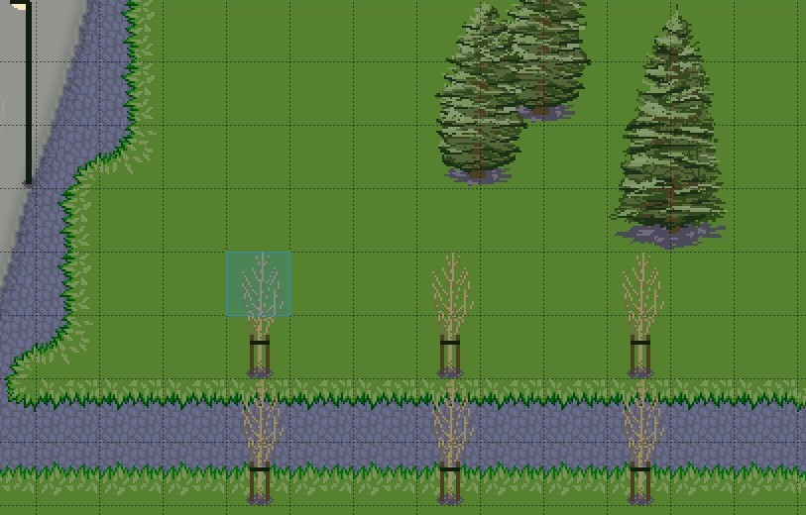Screenshot of the Tiled editor: several overlayed tiles in a 32x32 pixel grid
You can either design your own tilesets (e.g. with Photoshop/Krita/Gimp/…) or download a tileset from a website. Keep in mind to comply with the copyright of the artist!

Embed copyright hints
You can and should mention the author of external assets, that you used for your map. You can store the copyright information in a file that can be read by map visitors when clicking on the © icon. The file will be displayed as a regular text file in an embedded window.
The prerequisite is that the filename says COPYRIGHT (without any file extension).

